**Krisztian Der Cohort E17 PDA**

**DOB: 13/10/1985**

**Address: 2 Carrick Knowe Hill, Edinburgh, EH12 7BS**

**Evidence for Implementation and Testing Unit**

I.T 1 Demonstrate an example of encapsulation

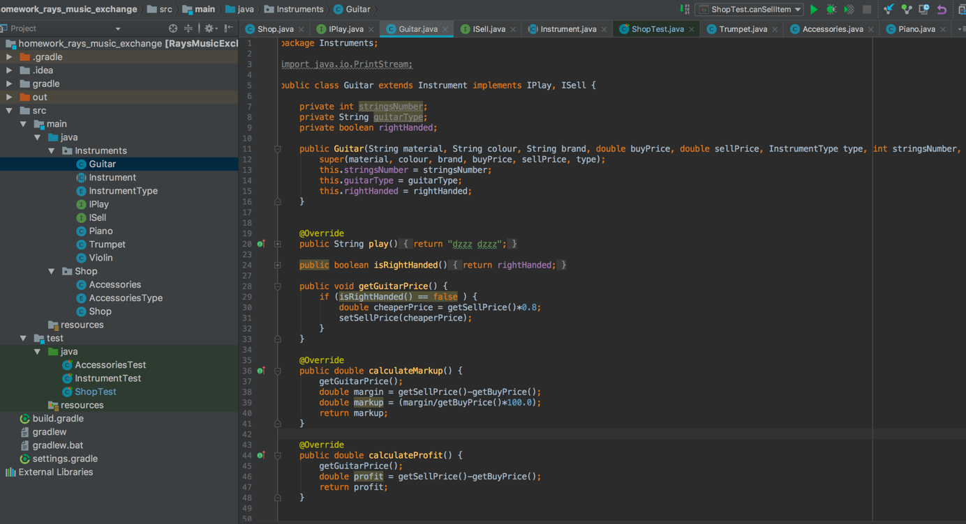

I.T 2 Example for the use of inheritance in a program

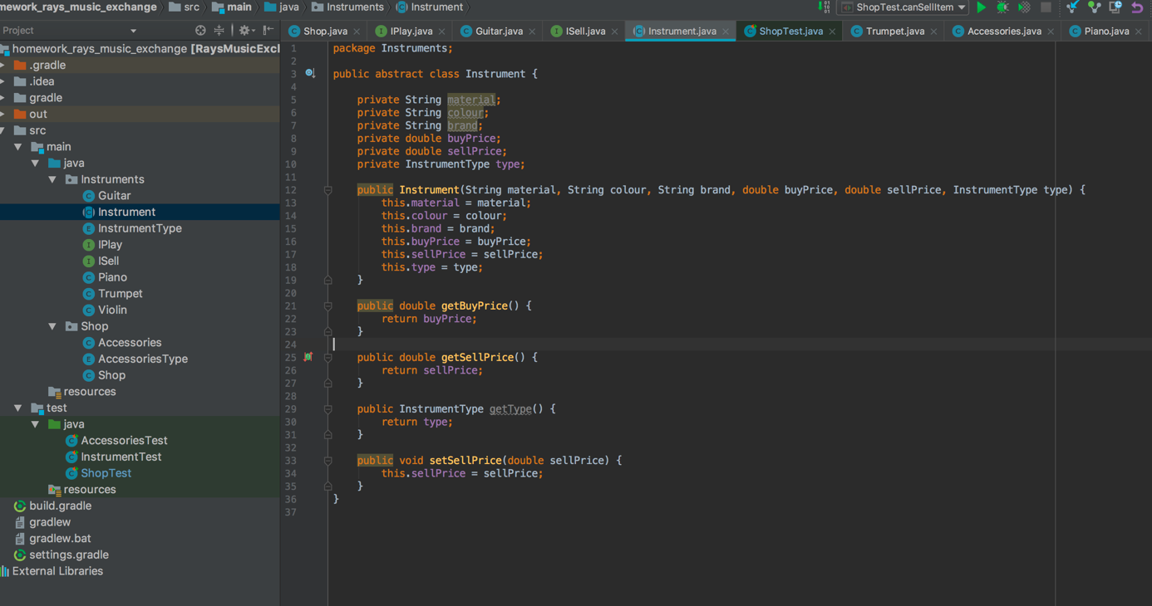

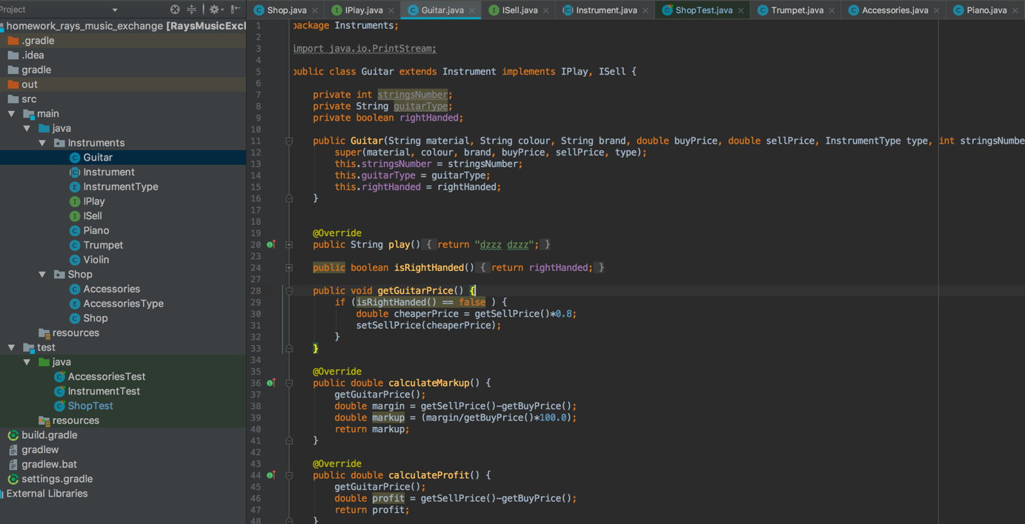

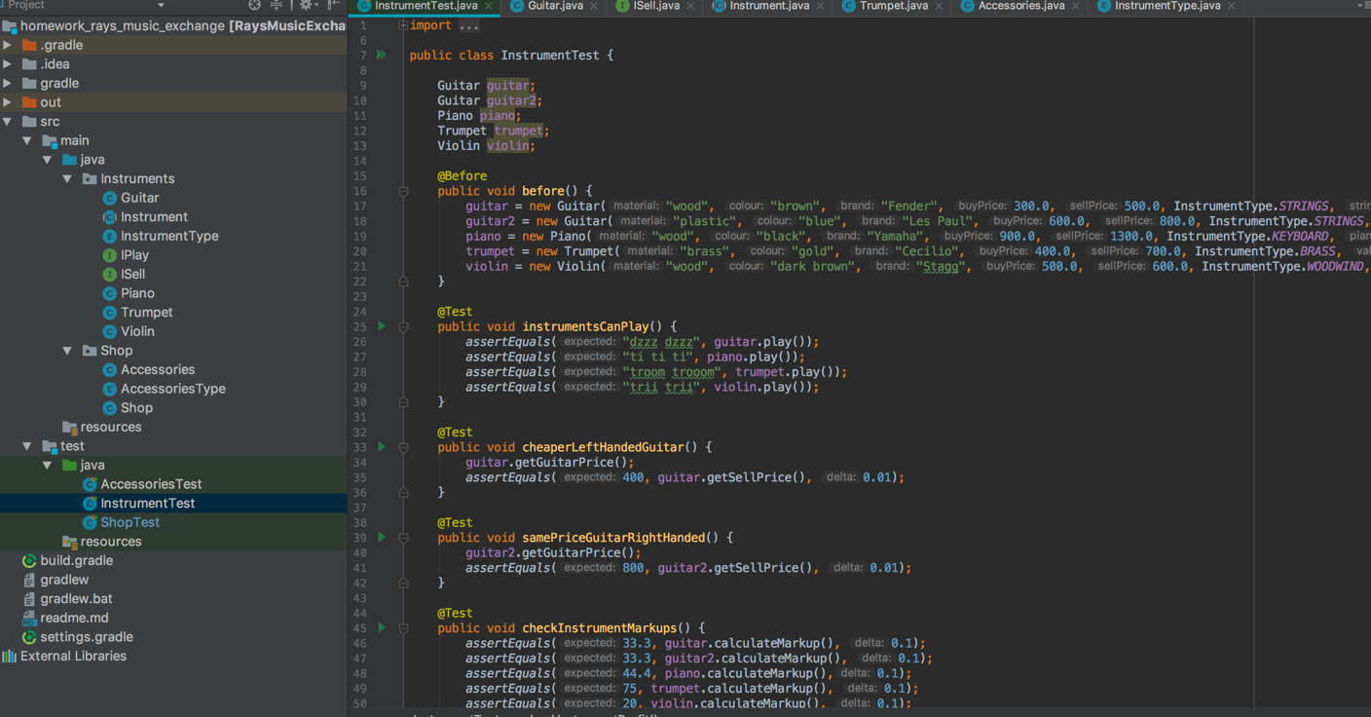

I.T 3 Searching data in a program

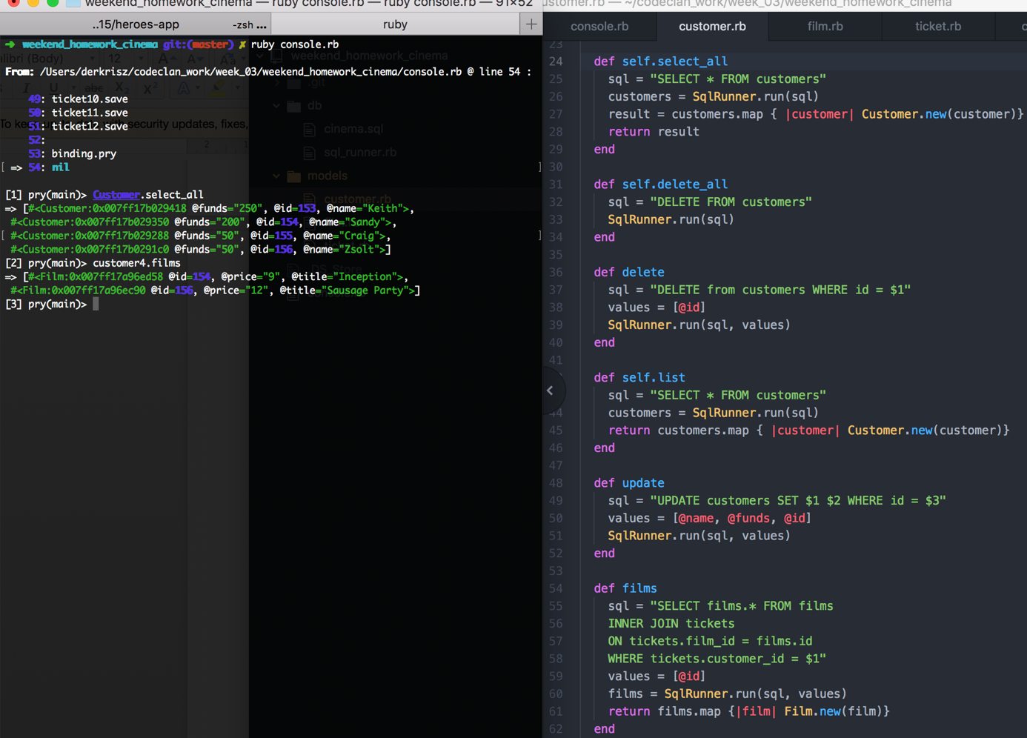

I.T 4 Sorting data in a program

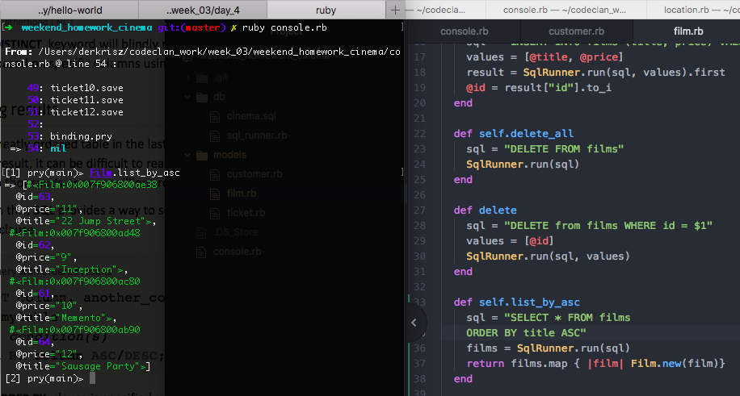

I.T 5 Use of array in a program

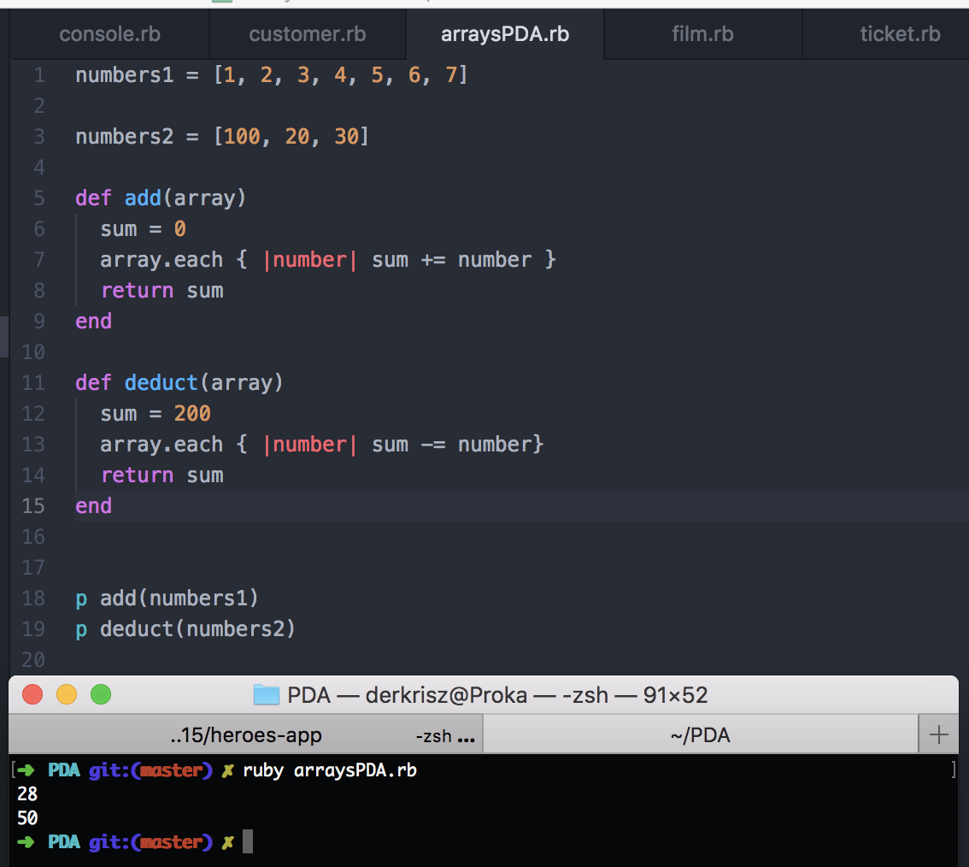

I.T 6 Use of a hash in a program

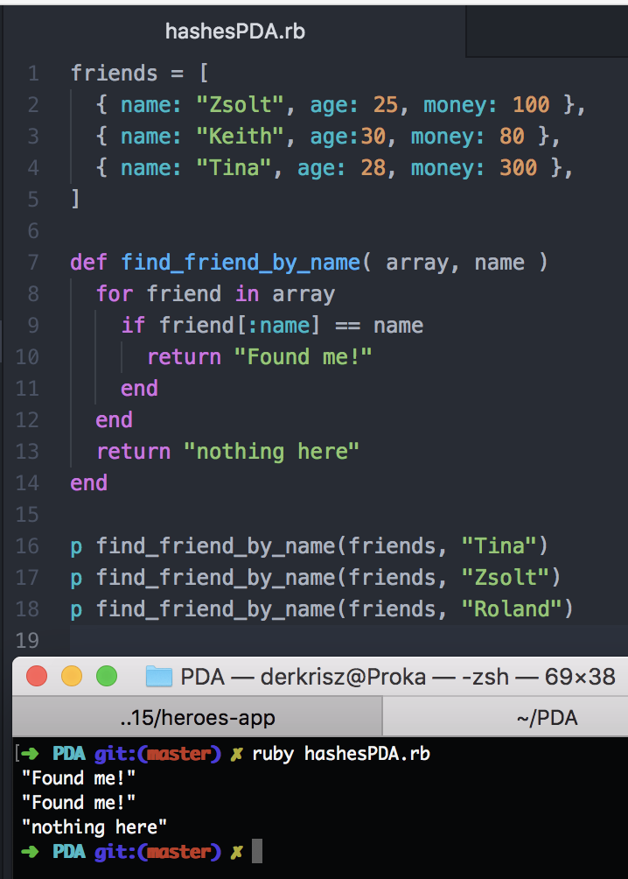

I.T 7 Use of polymorphism in a program

